# Git Insights

จำนวน 1 Repos

## Repo 1

### Commits

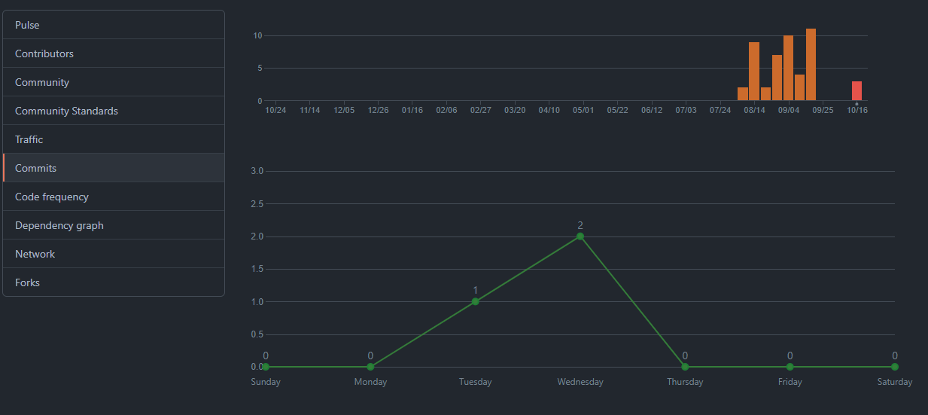

### Contributors

### Commit Messages

### Branch

